Lab 4 Report

Wenqian Ye
NetID: wenqian3

- Report item 0
1. [h,w] = freqz(b,a,n) returns the n-point frequency response vector, h, and the corresponding angular frequency vector, w, for the digital filter with numerator and denominator polynomial coefficients stored in b and a, respectively.It takes in 3 arguments b - numerator coefficients in the transfer function, a - denominator coefficient in the transfer function, n - the number of evaluation points that we desire between 0 and pi. The output is the frequency response.

2 . The first file approaches using z-transform to DFT, and the second file approaches using DTFT.
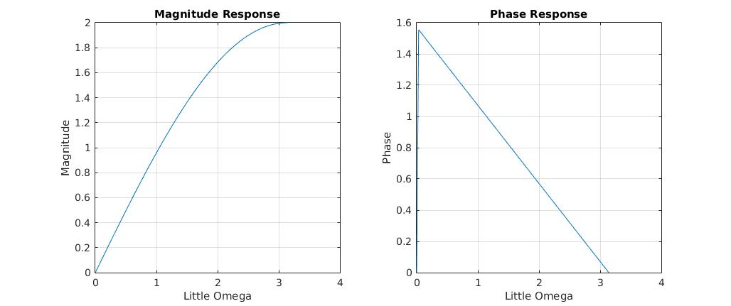
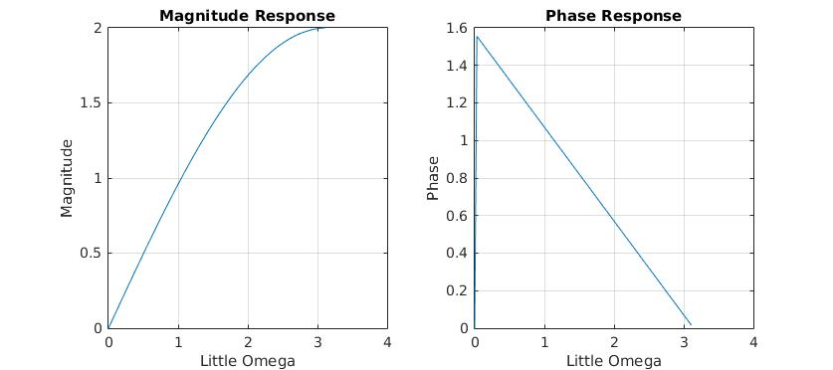
3. The two figure look the same. But for the w > 3.1102, the first figure miss this part. The reason is that for the first program, the ff only goes till 3.1102, so the plot is end when w = 3.1102.

4.

5. P = angle(Z) returns the phase angles, in radians, for each element of complex array Z. The angles lie between ±π.
Y = phase(X) returns the phase angles of a signal, in radians, the phase lie between -infinite to +infinite.

- Report item 1
(1).

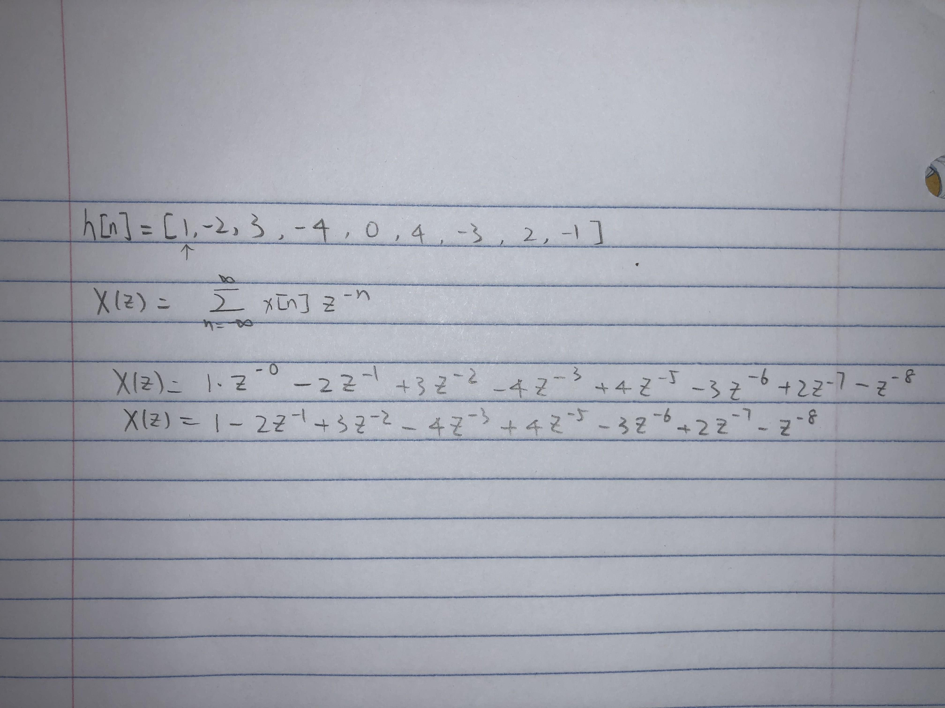
H(z) = 1 - 2z-1 + 3z-2 - 4z-3 + 4z-4 - 3z-6 + 2z-7 - z-8
Hd(ω) = 1 − 2e^(−jω) + 3e^(−2jω) − 4e^(−3jω) + 4e^(−4jω) − 3e^(−6jω) + 2e^(−7jω) − e^(−8jω)
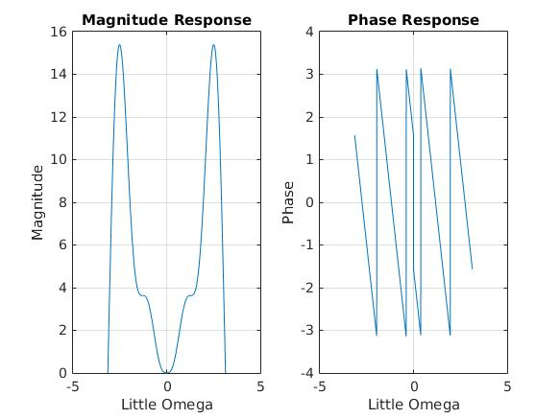
(2).

(3).
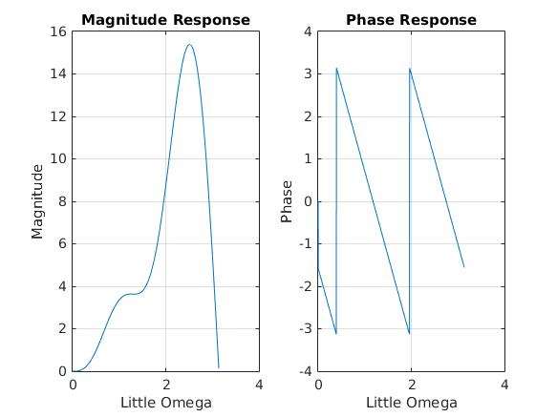

The responses are the same. The freq() are wrapped between -pi and pi, but looks like the same as (3).

- Report Item 2

(1)
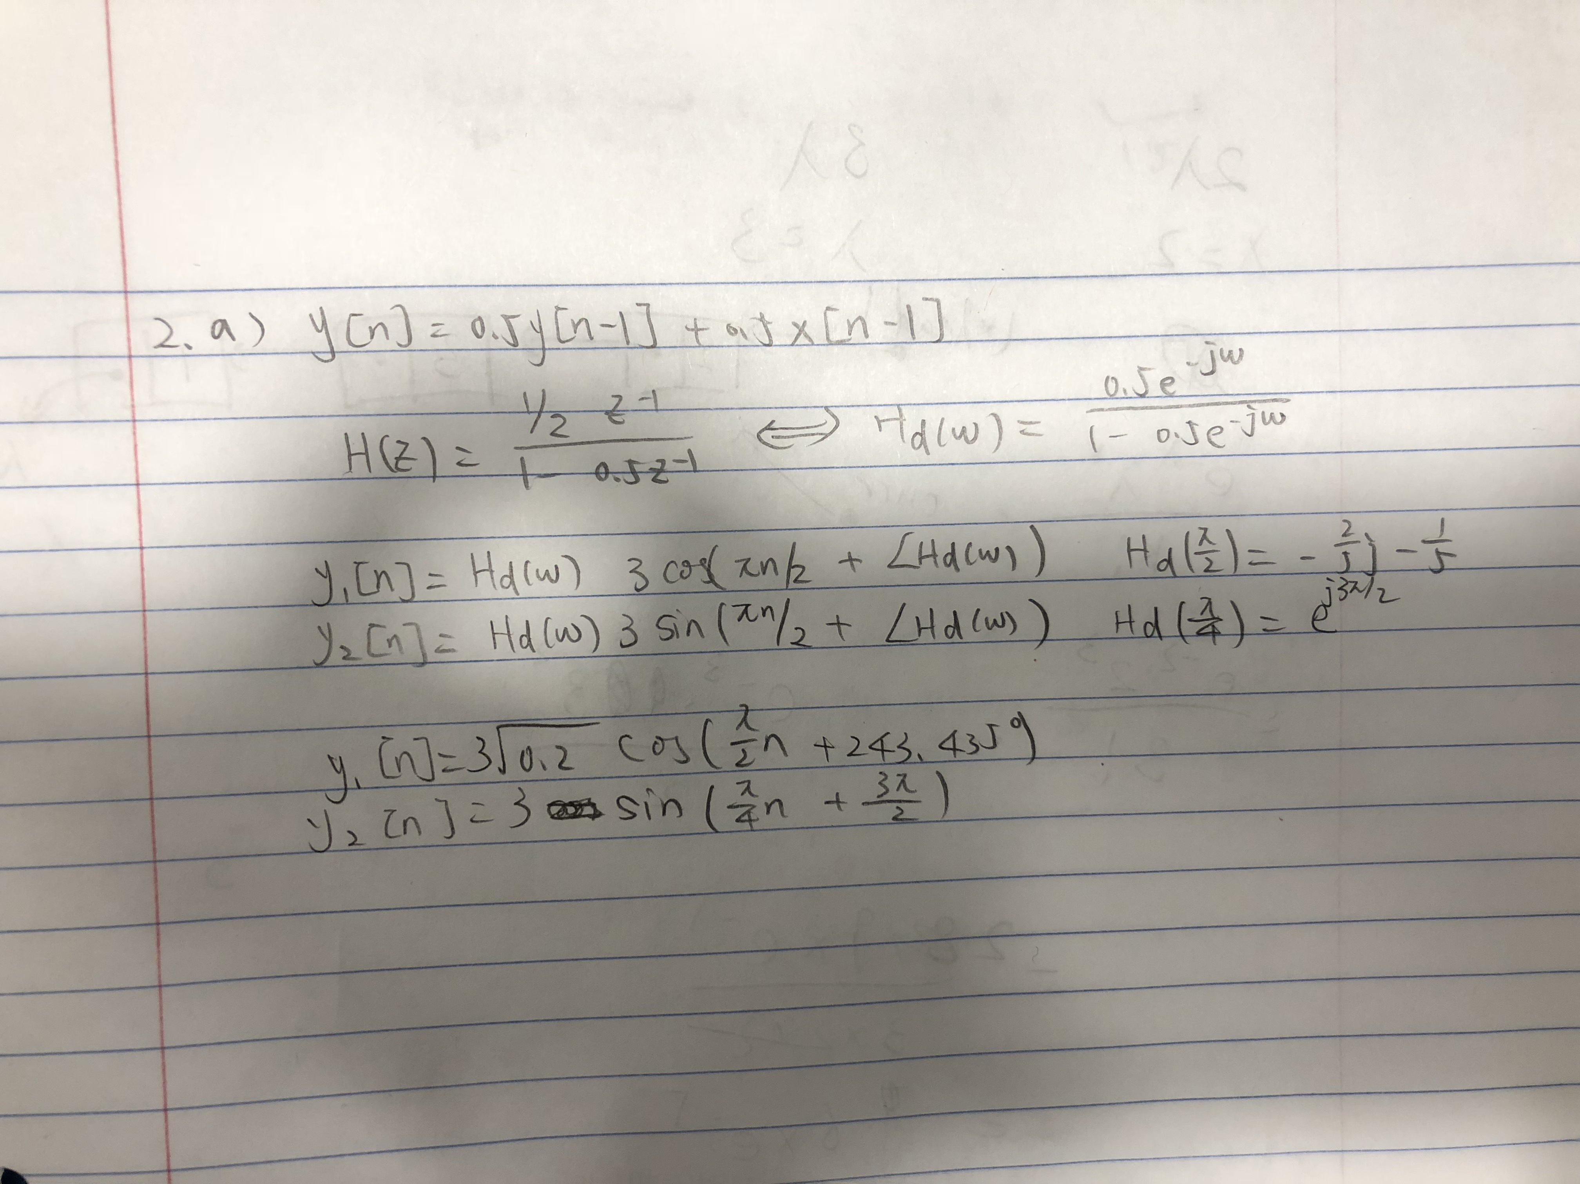
(2)

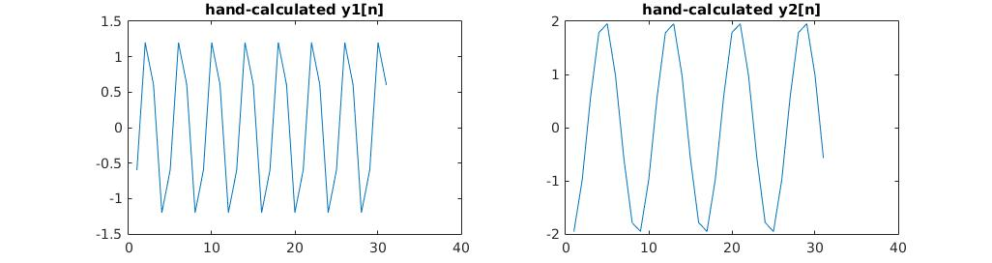

(3)
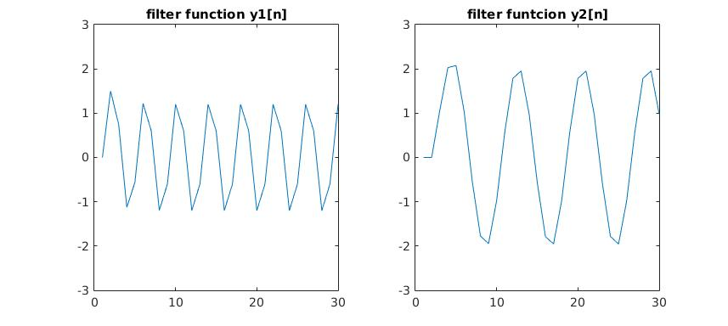
(4)
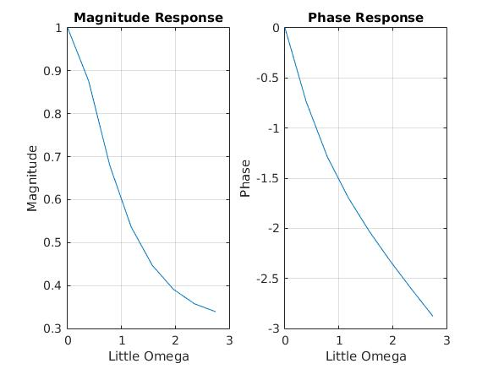

(5). (2) and (3) are different. They have the same shape but looks like both y1[n] and y2[n] computed from hand is shifted right relative to those from filter function.

- Report Item 3
(1)

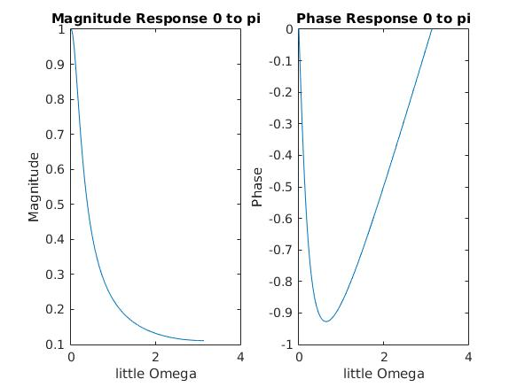

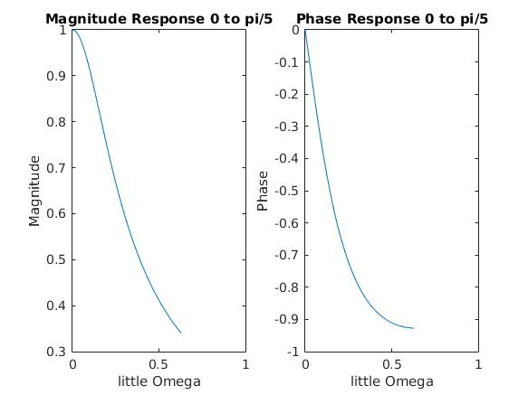
(2)
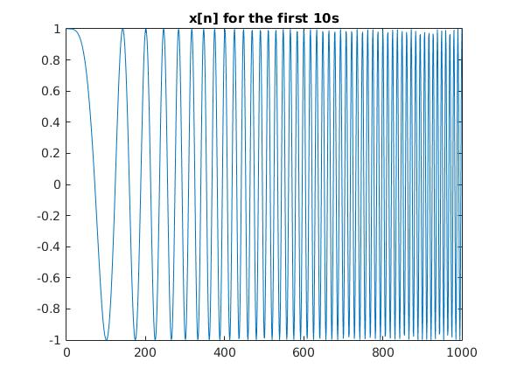

(3).
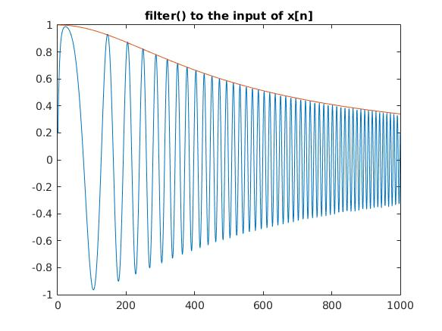

Each instantaneous frequency at time sample n is equal to the frequency at index n of the frequency response, making this valid.

- Report Item 4

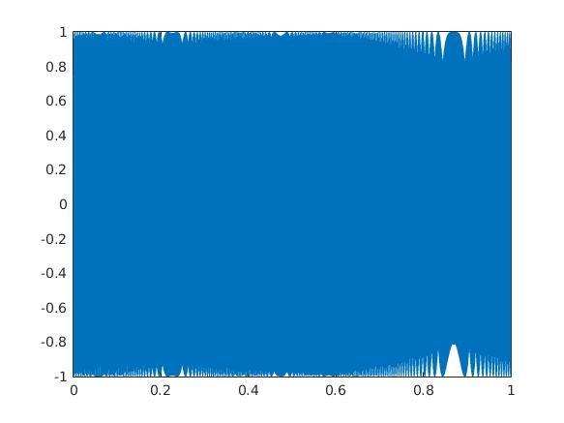
(2).I heard a high frequency increasing in pitch

(3).
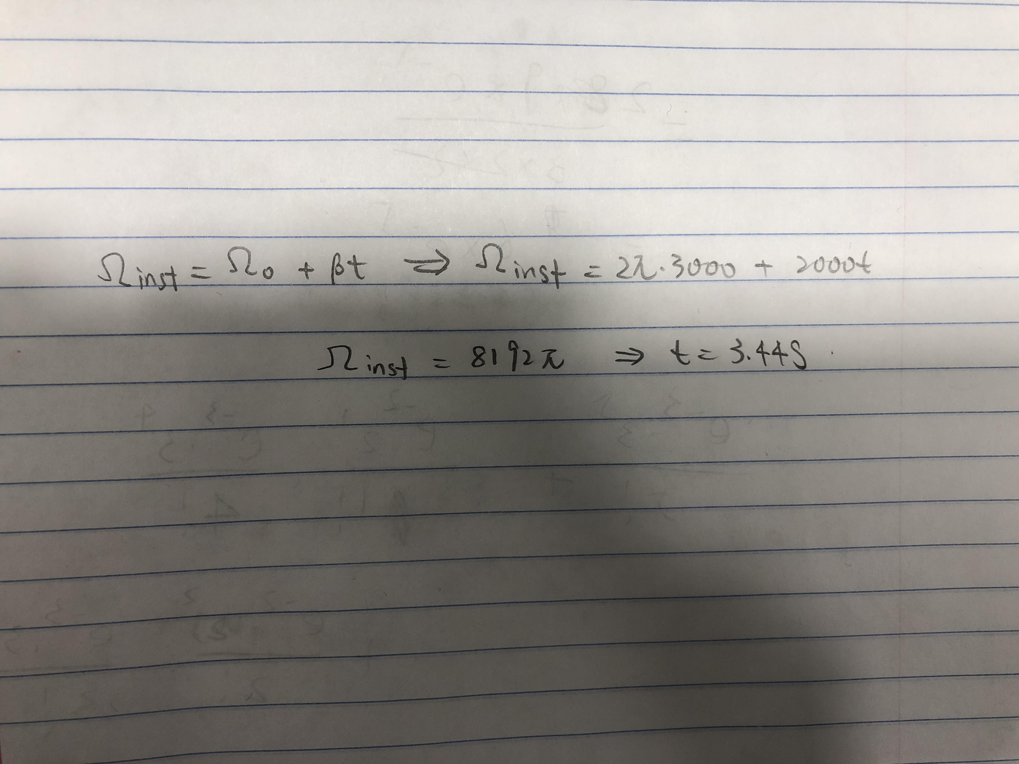

(4).
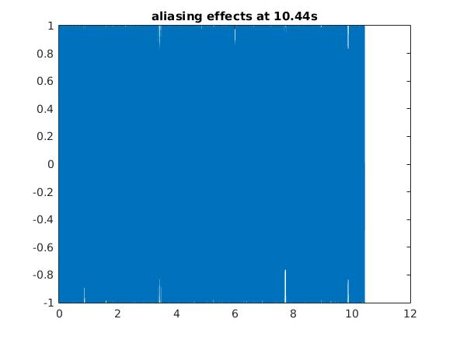
I hear some decreasing frequencies.

